Relationship between Hardware and Software
 Mutually dependent. Both of them must work together to make computer produce a useful output. Software cannot be utilized without supporting hardware.
Hardware without set of programs to operate upon cannot be utilized and is useless.
To get a particular job done on the computer, relevant software should be loaded into the hardware. Hardware is a one-time expense.
Software development is very expensive and is a continuing expense. Different softwares can be loaded on a hardware to run different jobs. A software acts as an interface between the user and the hardware.
If hardware is the 'heart' of a computer system, then software is its 'soul'. Both are complimentary to each other.

SOFTWARE
- Software is a set of instructions that drive a computer to perform specific tasks.
- These instructions tell the machine‟s physical components what to do.
- A set of instructions is often called a program.
- When a computer is using a particular program, it is said to be running or executing the program.
- The two most common types of programs are system software and application software.

TYPES OF SOFTWARE
Computer software is broadly divided into two categories namely:
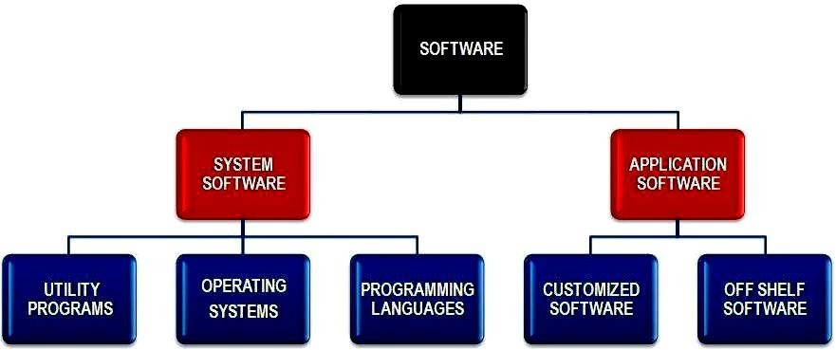
  - System software
  - Application software
SYSTEM SOFTWARE

This consists of programs that control or manage the operation of the computer and its devices. System software serves as an interface between users, the application its software and the computer's hard ware.
System software is computer software designed to operate the computer hardware and to provide maintain a platform for running application software.

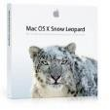
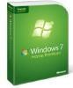
Examples of system software include;
 The operating system Utility Programs
Programming language

OPERATING SYSTEM
This is a set of programs containing instructions that co-ordinate all the activities among hardware resources.
▣ In otherwords, an operating system is a computer’s master control program.
▣ It provides a user with the tools (commands) that enable him/her interact with the computer.
▣ It also acts as a primary controlling mechanism for the computer‟s hardware.
▣ Without an operating system, a user cannot run an application program on their computer.

Classification of operating system
- Real-Time operating Systems:
  - Refers to multitasking operating system that aims at executing real-time applications.
  - A real time application is an application that responds to certain inputs extremely quickly.
  - Very fast and relatively small operating systems.
  - Built into a device, not loaded from a disk drive.
  - Used in MP3 players, Medical devices such as medical diagnostics equipment, life-support systems etc.

- Single-User/Single-Tasking Operating Systems:
  - Allows a single user to perform just one task at a time
  - Take up little space on disk
  - Run on inexpensive computers
  - Examples include; MS-DOS and Palm OS for palm handheld computers.
- Single-User/Multi-Tasking Operating Systems:
  - Allows a single user to perform two or more functions at once.
  - Commonly used on personal computers.
  - Examples include; Microsoft Windows and MAC OS.
- Multi-User/Multitasking Operating Systems:
  - Allows multiple users to use programs that are simultaneously running on a single network server.
  - Here, each user is given a user session on the server.
  - UNIX, Linux are examples.
  - Maintenance can be easy.
  - Requires a powerful computer.

FUNCTIONS OF OPERATING SYSTEM

i. The operating system manages the computer devices (Device manager)

ii. It conducts the process of booting or starting the computer (starting a computer)

iii. ii It acts as a file manager (file management):

iv. Operating systems often provide users with the capability of managing files, viewing graphics files, uninstalling programs, scanning disks.

v. It acts as an interface between the computer and the user(providing a User interface)

vi. It provides the means for proper user of the resources like monitor, memory, input and output devices,

vii. It interprets the program instructions one at a time (managing programs):

viii. Some operating systems support only one running program at a time others support thousands of users running multiple programs.

ix. The operating system is the processing management,

x. It loads the user program into the memory,

xi. It gives instruction to display the results on the monitor.

xii. It also manages me printing process: me operating system determines the order in which jobs are processed. A job is an operation that the processor manages.

xiii. Memory management: the purpose of memory management is to optimize the use of Random Access Memory.

xiv. The operating systems allocates, assigns data and instructions to an area of the memory while they are being processed.

xv. Configuring Devices: A driver is a small program that tells the operating system how to communicate with a specific device. When you boot the computer, the operating system loads each device's driver. These devices will not function without their correct drivers.

xvi. Controlling a network: Some operating systems are network operating systems.

A network OS is an operating system that organizes and coordinates how multiple users access and share

resources on a network resources including hardware, software, data and information. It has more security features than other OS.

Examples of operating system

i. Windows XP

ii. Windows2000

iii. Fedora

iv. Ubuntu

v. Linux

vi. UNIX

vii. Novel Netware

viii. Macintosh

ix. Window server

TYPES OF USER INTERFACE
The two most common types of user interfaces are graphical and command line.

GRAPHICAL USER INTERFACE (GUI)
These are interfaces which use icons, small pictures and viewable images to issue commands.
You are provided with a coloured screen with lines (bars) each representing a program and a mouse.

Graphical user Interfaces (GUI):
- Most common interface used in versions of; Windows, MAC OS, in some versions of LINUX and UNIX.
- Uses a mouse to work with graphical objects such as windows, menus, icons, buttons and other tools.
- Can use Shortcuts to open programs or documents.
- It enables task switching.
- Advantage: It frees a computer user from memorizing and typing text commands.

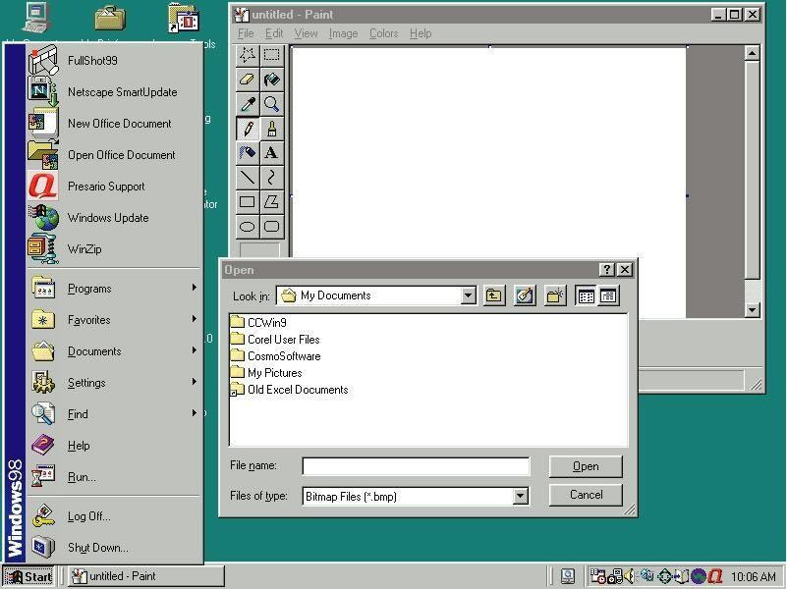

COMMAND LINE USER INTERFACE
These are interface where commands are issued by typing special keys on the keyboard, a user is provided by a blank screen with a blinking cursor called a prompt. Example includes DOS, Linux.

- Command Line Interface
  - Older interface used in MS-DOS, Linux, UNIX
  - User types commands at a prompt to execute tasks.
  - User must remember all commands.
  - Windows also has an optional command prompt that can be used by administrators to run non-GUI programs for managing and troubleshooting windows.

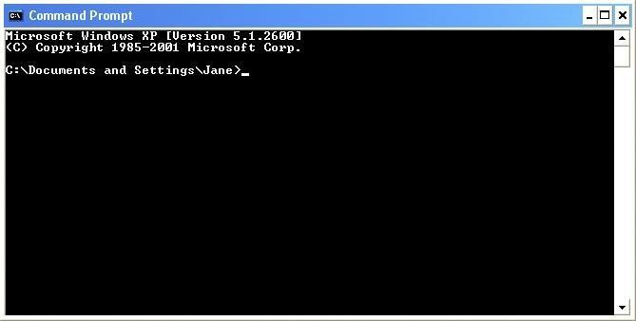

DIFFERENCES BTN COMMAND LINE AGRAPHICAL USER INTERFACES.
COMMAND LINE | WINDOWS (GRAPHICAL USER INTERFACE
Interface takes up little memory and doesn‟t require very  fast processor. | Needs or requires more memory as well as a faster  processor.
Operation is fast because commands can be entered  directly through the keyboard | Operation on the windows environment depends on the  powerfulness of the processor.
Many commands can be grouped together as a batch file  so that repetition task can be automated. | It is difficult to automate functions for expert users.
Commands can be learnt | Graphical user interface is a user friendly because it is  easy to learn and work with.
Commands have to be memorized | Commands do not need to be memorized because the  commands are represented with icons and pictures.
NETWORK OPERATING SYSTEMS (NOS)
These are operating systems that have additional features that allow computers to be networked, they have advanced security features.
A network operating system organizes and coordinates a multiple users access and share resources on a network, resources including hardware, software, data and information.
A network operating system allows computers to communicate and share data across a network while controlling
network operations and overseeing the network‟s security. Example is Windows server 2003.

Examples of NOS include:-
i. Novel Netware
ii. Windows NT server.

iii. Windows 2000 server.
iv. UNIX

APPLICATION SOFTWARE.
It consists of programs that perform specific tasks to a user. Application software is used for a variety of reasons.
As a business tool.
To assist with graphics and multimedia projects
To support home, personal, and educational activities. To facilitate communication
Most application softwares are available as packed software that can be purchased in a software shop or the web. Application software is available of forms. i.e. packages (off-shelf) custom, shareware, freeware and public domain.

Packaged software (off-shelf)
This is a mass produced, copy written retail software that meets the needs of wide variety of users not just a single user or company. Application software are available in general nature

Custom software
These are software designed to meet the needs of a particular organization or user (consumer) and performs function specific for the business or industry. Sometimes the company cannot find package software that meets its requirement so it orders for a custom software

Shareware
This is a copy written software that it is distributed free for a trial period
To use a share ware program beyond that period you send the payment to the person or a company that developed that program

Free ware
This software is provided at no cost to a user by an individual or a company

Public ware
Is an application software that is designed for the public.

Starting and interacting with an application software
To use application software you must instruct the operating system to start the program
EXAMPLES OF PACKAGED SOFTWARE.

WORD PROCESSING / WORD PROCESSORS.
This one of the more widely used type of application software. Word processors are application soft wares used to create and manipulate documents like reports, memos, letters e.t.c and sometimes contain graphs

Examples of word processors include

i. Microsoft word.

ii. Sun star office writer

iii. Corel word perfect (DOS editor). Word processor that uses the keyboard to operate

iv. Word pad

COMMON FEATURES OF WORD PROCESSING APPLICATIONS
i. Word Wrap: this feature automatically sends a word that does not fit within the margin settings onto the next line, without the user pressing Enter key.
ii. Find: allows the user to locate all occurrences of a particular character, word or phrase.
iii. Replace: allows the user to substitute existing characters, words or phrases with the new ones.
iv. Spell checker: allows the user to check spellings of the whole document at one time or to check and even correct the spelling of individual words as they are typed (Autocorrect)
v. Grammar checker: this reports grammatical errors, usually by a wavy green line, and suggests ways to correct them.
vi. Thesaurus: suggests alternative words with the same meaning (synonyms) for use inthedocument.
vii. Mail Merge: This is feature used to create similar letters to be sent to several people. The names and addresses of each person can be merged with one single main document.
viii. Automatic page numbering: numbers the pages automatically in a document
ix. Tables: allow users to organize information into rows and columns.
x. Multi-columns: arranges text into two or more columns that look similar to newspaper or magazine
xi. Drop cap – Formats the first letter in paragraph to be dropped across two or more lines.
xii. Clipart: refers to pre-made images about various subjects used to illustrate concepts in documents.
xiii. Templates: establish the initial document layouts and formats for various document types.
xiv. Printing: allows a user to obtain a hard copy of a document from the printer.
xv. Word Count: Establishes the number of words, characters, paragraphs, etc. in a document.
xvi. Headers and Footers: Used to insert text in the top and bottom margin through the document.
xvii. Footnotes and Endnotes are used as references that provide additional information about a word or phrase within a document.
xviii. Insert and Delete allows a user to add and remove portions of text while editing document.
xix. Bold, Underline, Italic – These and other format features that allow a user to improve on the appearance of text.
xx. Cut, Copy, Paste, Insert, Delete – These and other editing features that enable a user to make changes to the text in a document.

2. SPREADSHEET SOFTWARE
Spreadsheet software is software that allows users to organize data in rows and columns and perform calculations on the data.
A spread sheet package is a program with some aspects of a filing system and some of a calculator. The program will do calculations as instructed by you. It is used to re-calculate automatically.
This is used to organize and calculate data in rows and columns collectively they are called work sheets. Examples of spreadsheets
i. Microsoft excel
ii. Lotus 1-2-3
iii. Visual calc
iv. Symphony
v. Corel Quattro pro
vi. Sun star Office calc
vii. Apple Pages,

Qn: Discuss the merits and demerits of using electronic spreadsheets over manual spreadsheets. Merits:
  - Easy to make changes and corrections (ease of edit and format) to data on the worksheet.
  - Electronic spreadsheets can perform mathematical, statistical, and financial calculations quickly and accurately.
  - The rest of the worksheet is recalculated whenever data in one place changes.
  - Spreadsheets have built-in functions and macros which made work easy.
  - Calculation is always accurate, provided that data and formulae entered are correct.
  - They offer different options of data presentation such as pie charts, bar graphs, etc.
  - They are very useful for applications that require modeling and what-if analysis.
  - They easily filter, sort, and arrange data in alphabetical order for better organization.
  - Workbooks can be saved in soft copies that can be easily modified and reused in future.

Demerits:
  - Need for specialized software and hardware which is expensive.
  - Spreadsheets require enough time for training and practicing before use.
  - There is a lot of complexity surrounding formulas, functions and their arguments.
  - May lead to loss of data. Computers are prone to system errors, power outages and virus infections. These problems also can affect access to your electronic spreadsheet; in extreme circumstances, it could mean a total loss of data.
  - Difficulty in finding Data Mistakes. Electronic spreadsheets are known for having numerous fields, sometimes in different sizes, making it look like a screen full of small boxes. Working with such a large volume of data at one time makes it challenging to spot and correct errors within the document.
  - Difficult printing: Obtaining hard copies becomes very hard especially when the worksheets are wide as compared to the available page sizes.

Qn: with Examples, distinguish between an Absolute cell reference’ and a Mixed cell reference.

An absolute cell reference is one that always refers to a spreadsheet cell in a specific location and cannot change when copied to other cells. For example $A$1, $AD$126, etc. (has both column letter and row number fixed)

While
A mixed cell reference is one that both relative and absolute arguments. It has either an absolute column and a relative row e.g. $B4, or a relative column and an absolute row e.g. B$4. Only the relative argument changes when the reference is copied to other cells.

DATABASES
This is a program that allows users to store data in an organized way well as retrieve, manipulate and display that data in a variety of formats
Microsoft Access is one of the popular database software.

Examples of Data bases

i. Microsoft Access

ii. Microsoft Visual Fox Pro

iii. Borland Dbase

iv. Lotus Approach

v. Corel paradox

vi. Oracle

vii. Sun star Office base

viii. Visual Basic

PRESENTATION SOFTWARE
This allows users to create a visual aid presentation, it enables you to create, organize and design effective presentation.
It can also be defined as a way of delivering the information to the audience in a manner that connivances them or changes their understanding or attitude.
Examples of presentation softwares,
i. Microsoft PowerPoint,
ii. Flash MX.
iii. Sun star Office impress
iv. Corel presentation.

COMPUTER AIDED DESIGN (CAD)
This is a software that assists professional users in creating engineering architectural and science designs e.g. engineers design plans and security systems

Examples of CAD

i. Autodesk Auto card

ii. Quality plan Chief Architect

iii. Microsoft office Visio 2003

iv. Arch card

DESKTOP PUBLISHING SOFTWARE (DTP)
This enables professional designs to create decorative documents that contain text, graphics and many colours. It is an ideal producing high quality documents such as book covers e.tc.

Examples of Desktop Publishing software

i. Adobe InDesign

ii. Adobe page maker

iii. Adobe paint maker

iv. QuarkXPress

v. Corel VENTURA

GRAPHICS / IMAGE EDITING SOFTIWARE.
Graphics artist use graphical software to draw pictures and design text and other graphical images with an on screen tools such as a pen brush, eye dropper text etc.

Examples of graphics/ images editing soft ware

i. Adobe photo shop

ii. Adobe illustrator

iii. Corel draw

iv. Paint

v. Print artist

vi. Corel Painter.

VIDEO AND AUDIO EDITING SOFTWARE
Video editing software allows users to modify a segment of video, called a clip for example you can reduce the length of a video clip. Or add special effects such as words that move horizontal across the screen. Video editing software often includes audio editing capabilities.
Audio editing software: This lets users modify audio clips and produce studio quality sound tracks. Audio editing software usually includes filters. Which are designed to enhance audio quality.

Examples of video and audio editing software.
i. Adobe audition
ii. Adobe encore DVD
iii. Adobe Premiere Pro
iv. Pinnacle system studio DV
v. Ulead Media Studio DV
vi. Macromedia sound edit.

ACCOUNTING SOFTWARE
Used for preparing payrolls, capturing cash inflows and outflows, generating financial statements as well as balance sheets, etc.
Accounting software helps companies record and report their financial transactions. With accounting software, business users perform accounting activities related to general ledger, accounts receivable, accounts payable, purchasing, invoicing, and payroll.
i. Intuit QuickBooks
ii. Peachtree complete accounting.
iii. Tally

